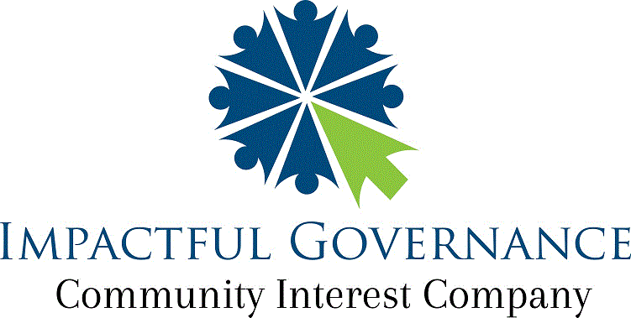
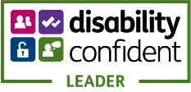

“Creating sustainability by imbuing independence and strength into organisations;

supporting services to be more effective and efficient”

Pre-interview questionnaire

Learning difficulties or disabilities
Do you consider yourself to have any of the following? |  |  | ☐ Yes ☐ No
If Yes, please tick one or more of the following boxes:
Disability, Learning Disability/Difficulty or Autism
Visual Impairment | ☐ | Asperger’s Syndrome |  | ☐
Hearing Impairment | ☐ | Temporary disability after illness or accident |  | ☐
Disability affecting Mobility | ☐ | Speech, Language and Communication Needs |  | ☐
Profound Complex Disabilities | ☐ | Other Physical disability |  | ☐
Social and Emotional Difficulties | ☐ | Other specific learning difficulty (e.g. Dyspraxia) |  | ☐
Mental Health Difficulty | ☐ | Other medical condition (e.g. epilepsy, asthma, diabetes |  | ☐
Moderate Learning Disability | ☐ | Other Learning Difficulty |  | ☐
Severe Learning Disability | ☐ | Other Disability |  | ☐
Dyslexia | ☐ | Prefer not to say |  | ☐
Dyscalculia | ☐ | Not provided |  | ☐
Autism Spectrum Conditions | ☐
Which of the ABOVE learning disability, learning difficulty or health issue do you consider to be your main disability, learning difficulty or health issue:
……………………………………………………………………………………….
……………………………………………………………………………………….
……………………………………………………………………………………….
……………………………………………………………………………………….

Do you have an Education, Health and Care Plan? | ☐ Yes ☐ No
Do you have a Learning Disability/Difficulty Assessment? LLDD | ☐ Yes ☐ No
Do you consider yourself to require any support? | ☐ Yes ☐ No
If Yes, what support do you require?

Your Name: ……………………………………………………………………………………….

Position Applied for: LGBTQ+ Supporter

Date: 2nd February 2023

Winners of:
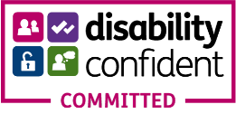

Finalists 2019 Governance Professional of the Year:
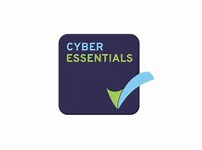
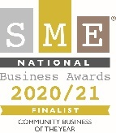

Person Specification: Individual Mentor (1-1) in-person/on premises

Essential Criteria | Desirable Criteria
- Experience of working with LGBTQ+ people. | - Experience working with client groups that have multiple barriers.
- Able to contact participants, encourage participation in events or activities or act as a Host to welcome LGBTQ+ people. | - Without micro-direction be able to tackle tasks within the project timeframes and report when needed i.e. safeguarding.
- MUST be available for various fixed days or evenings per week or month through a specified period (or event).  Annual leave will be available on request using our Leave Request form online. | - Own Home/office internet capability with min 50MB download and 10MB upload speed to avoid freeze-screen or drop-out during meetings and presentations.
- MUST have lived experience of an LGBTQ+ identity. | - Self-starter and able to use initiative to seek-out information.
- Good at speaking with people within our wider community. Working through our existing database, updating records and booking own work diary (Outlook). | - Ability to schedule Zoom or organize in-person meetings, sending invites and producing attendance reports and downloading video recordings as evidence.
- Engage participants onto LGBTQ+ events and attending such events, including monthly or annual events Like Herts Pride (Aug), Pride month (June) or LGBTQ+ History Month (Feb). | - Ability to organize own diary and invite participants and lead the delivery of content through small group discussions, gaining agreement.
- Giving presentations and using a smart work approach. | - A transportable (online) clean enhanced DBS clearance before commencing any in-person work.
- Organised, punctual and reliable. | - Current understanding of the various structures and models for LGBTQ+ community partnerships.
- Equality, Inclusion & Diversity ethos including self-awareness and difference. | - Able to be patient with groups that have specific clients that may need a higher level of empathy.
- Friendly, welcoming and empowering. | - Write brief reports and make recommendations in collaboration with the Chief Executive.
- A personable disposition and demonstrable interpersonal skills. | - Experience of supporting a range of other Disability clients i.e. sight, hearing, physical or other
- Experience of business-to-business communication or similar in a community role.
- Strong ethos for complete inclusion, Equality and diversity (i.e. disability, ethnicity & LGBTQ+)
- MUST have DBS clearance: if not available as a transportable version, a new one will be processed, prior to commencing in-post.

Email: ceo@ig-cic.org.uk Office: 01923 231660 Website: www.ig-cic.org.uk

Registered Office Address: The Old Free School, George Street, Watford, Hertfordshire WD18 0BX
Luton Office: West Wing Studios, Unit 16 The Mall, Luton, Bedfordshire LU1 2TL

Registered Community Interest Company Number: 1094080

Evidence of how you meet the Person Specification:

Essential Criteria | Desirable Criteria
 | 1
 | 2
 | 3
 | 4
 | 5
 | 6
 | 7
 | 8
 | 9
 | 10
 | 11

